Calculator Layout

The calculator is divided into four sets of questions covering common areas of individual consumption. ‘Food’ covers diet, food waste and buying habits. ‘Home’ covers energy type and usage in the house and the presence of energy-saving measures. ‘Travel’ covers personal and public transport usage for leisure and work, and flights. ‘Stuff’ covers the purchases of consumable items.

The questions have been designed to cover a cross-section of consumption behaviour, providing opportunities for users to explore options for reducing their carbon footprints. Questions are usually presented as multiple-choice options, with responses leading to an adjustment of the footprint from average levels

Questions and Calculations:

Food:

Q1: How would you best describe your diet?
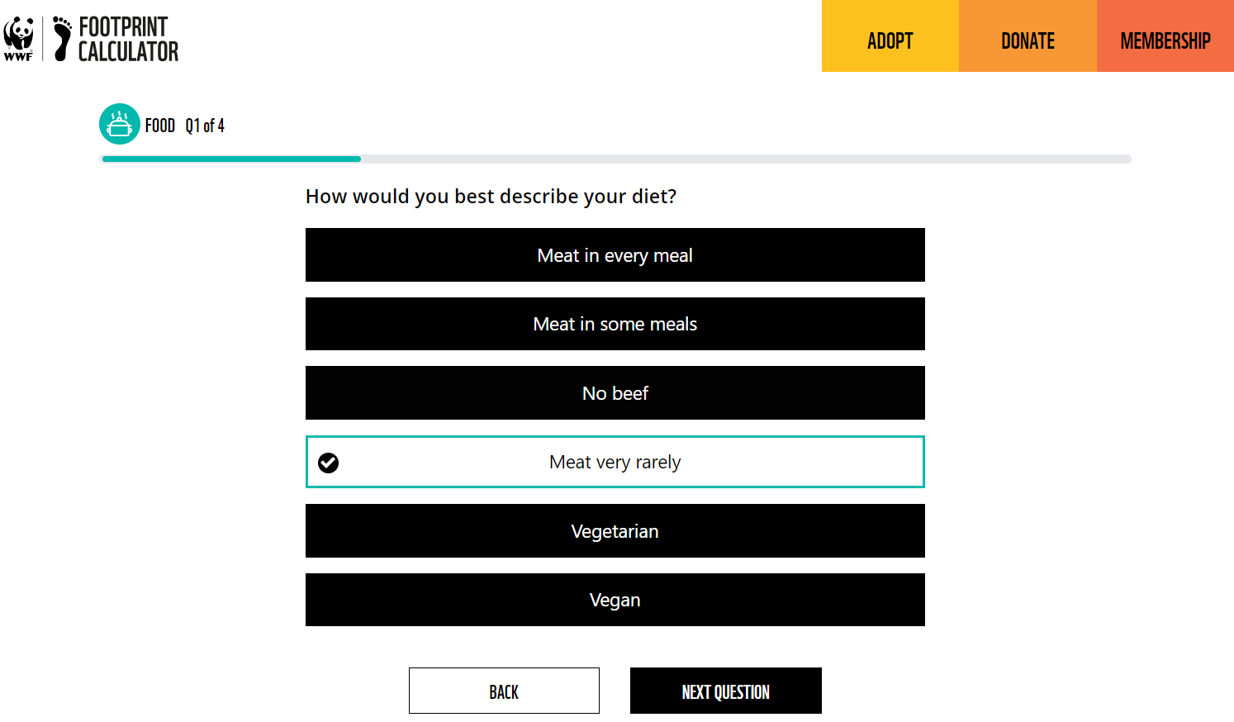

The user's dietary preference is being queried. The assumed average diet is meat in some meals (10% fat, sugar, oil, 20% meat, fish, dairy, eggs, 15% fruits, 25% vegetables, 30% cereals, bread).

An initial question is asked to modify the percentage distribution based on the diet. The options are:

-Meat in every meal (higher percentage of meat)
-Meat in some meals (average diet)
-No beef (only fish)
-Vegetarian (no meat/fish, + vegetables, cereals, and fruits)
-Vegan (no meat/fish, + vegetables, cereals, and fruits)

Climate Change Emission Factors:

-Dairy Products –
-Meat Products – Beef
-Fish Products
-Food products (not elsewhere specified)
-Vegetable oils and fats
-Sugar
-Fruit and vegetable juices (Only UK)
-Cereals (grains/bread/pasta) (Only UK)

Data Source: Exiobase 2021 – 59 Regions – Unit: kgCO2e/eur

Q2: In a week, approximately how much do you spend on groceries for your household, including food for meals prepared at home?

Our conversion factor obtained through the Climatiq API is measured in kgCO2e/eur (kilograms of carbon dioxide equivalent per euro). With this question, we determine how much the user spends over a period of time, let's say weekly. The total weekly amount is then divided proportionally based on the user's diet type. For example, if they spend 100 euros per week and have an average diet, it would correspond to (10€ fat, sugar, oil, 15€ meat, fish, dairy, eggs, 20€ fruits, 25€ vegetables, 30€ cereals, bread). Each amount is multiplied by its corresponding emission factor to obtain the equivalent in kgCO2.

-There could be a bar indicating the amount spent over the specified time period, or there could be 4 options with different weekly amounts.
-The question can be modified.
-We initially work with £?. In that case, there would be no problem, as conversions can be made.

Q3-In a week, how much do you spend on food from restaurants, canteens and takeaways?

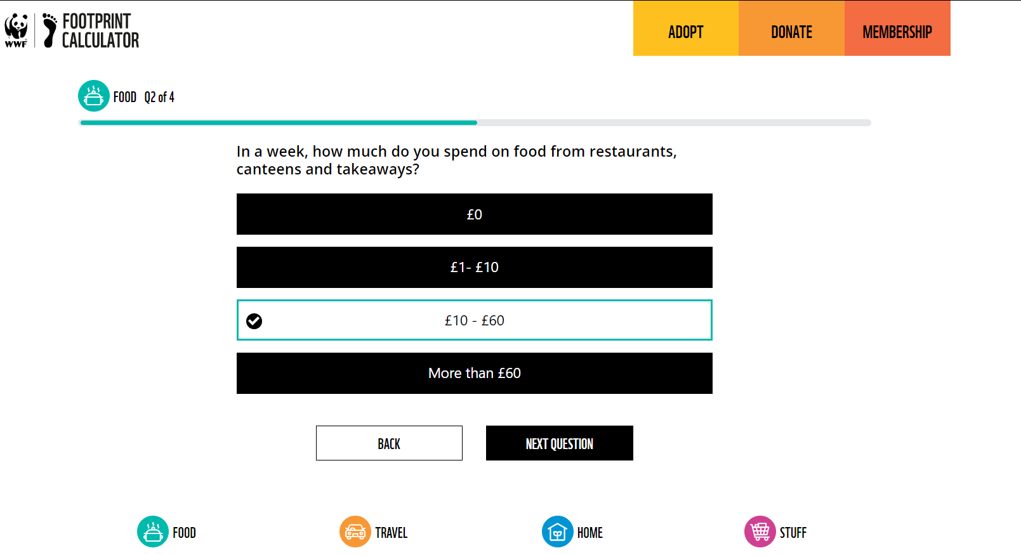

From Climatiq, we can access the following emission factors:

-Hotel and restaurant (services) (49 regions, exiobase 2019)
-Food and beverages services (dine-in and takeaway) (UK)

Based on the user's weekly spending amount, it is multiplied by the emission factor to obtain the corresponding amount in kilograms of CO2.

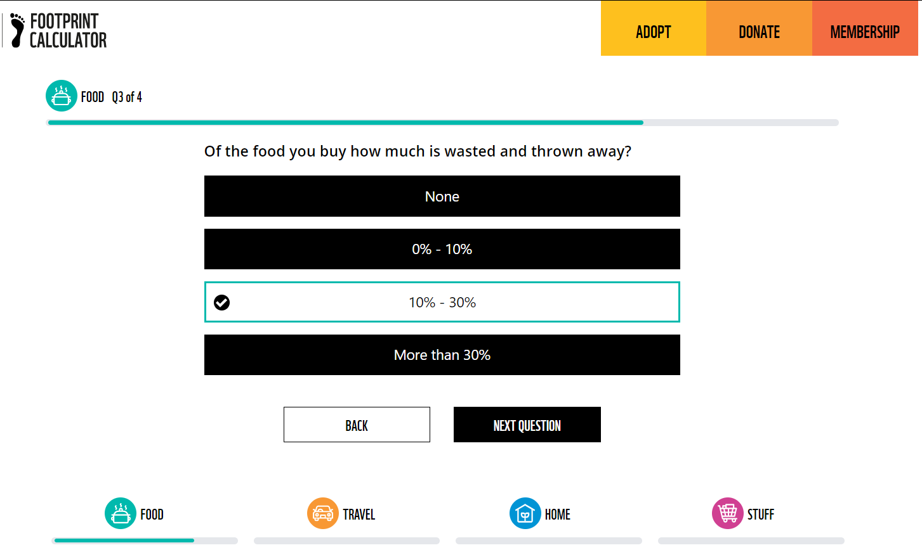
Q4: Of the food you buy how much is wasted and thrown away

( deals with food waste. We estimate that around 30% of the food bought
in the UK is thrown away and this question reduces the impact of users who consciously try to reduce their food waste. If the user selects ‘none’, their total food impact is reduced by 30%,
0-10% reduces their impact by 20%, 10-30% keeps the figure as it is because this is the UK
average and more than 30% increases the impact by 10%.) WWF Metodology Page 5

Bibliography

These four questions would constitute the food category in the calculator.

We could add any of the variables from the following image, as we have the corresponding factors for each one from the API. It would be related to data collection and determining which variables are more important for the company to know, although the idea is to keep it simple.

(https://www.carbonfootprint.com/calculator.aspx)
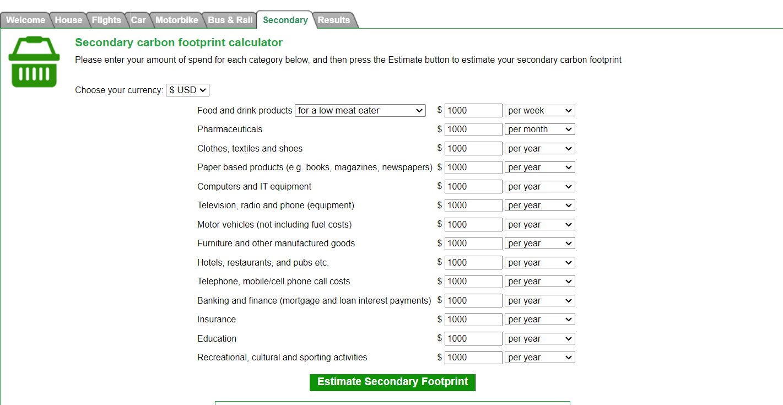

The information was obtained through the WWF Footprint Calculator Methodology Document 2021 and was also compared with (https://www.carbonfootprint.com/calculator.aspx).

Transport:

Q1- What kind of vehicle do you travel in most often as driver or passenger? (if any)
Hint: This question is finding out about your private car/motorbike use — we’ll ask about public transport next. If you walk or cycle everywhere, just click ‘Neither’.

The type of vehicle regularly used by the user is defined to determine the corresponding emission factor.
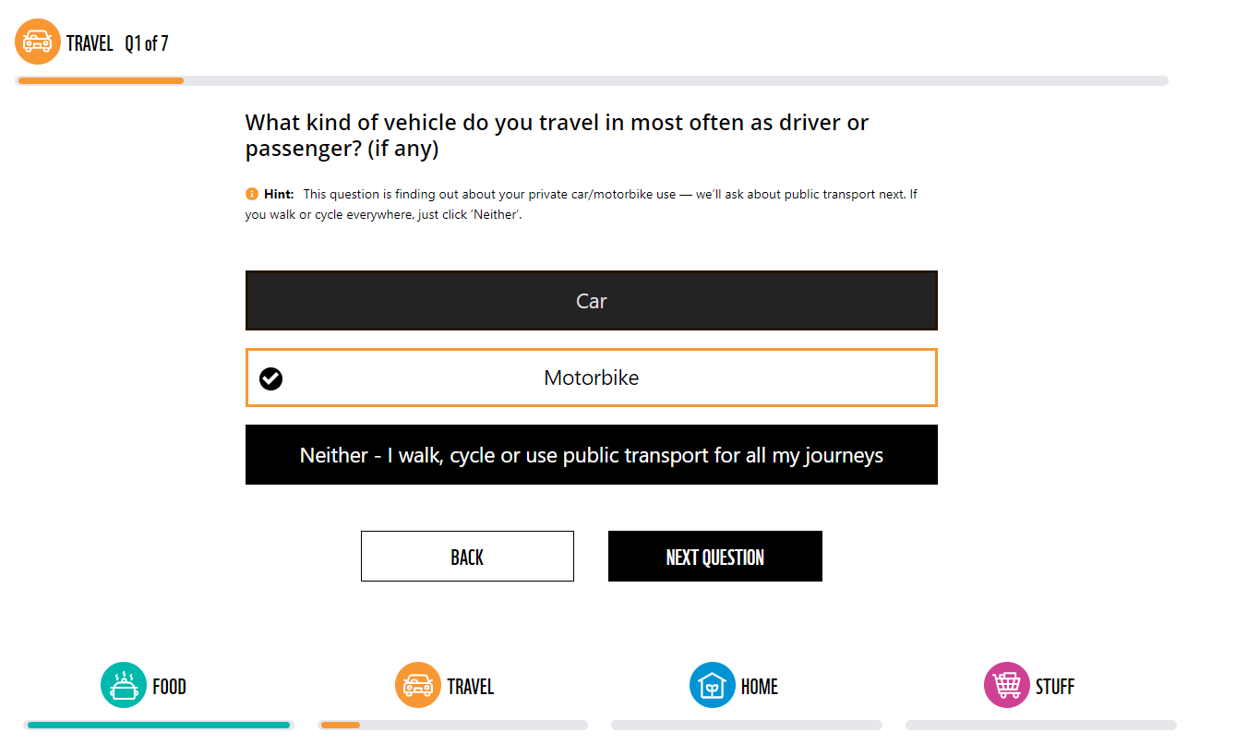

Factores de emision climatiq:
-Other transport equipment
-Car (average)
-Motor vehicles/trailers and semitrailers
-Railway transportation services
-Air transport services
-Other land transportation services
-Local London Bus
-+++

Data Source: Exiobase 2021 – 59 Regions – Unit: kgCO2e/eur

Q2- In a week, approximately how much do you spend on combustible for these vehicles?

With this question, we estimate the amount spent in a certain period of time, and we can multiply it by the corresponding emission factor to obtain the equivalent in kgCO2

Q3-How many hours a week do you spend on the train for personal use including commuting?

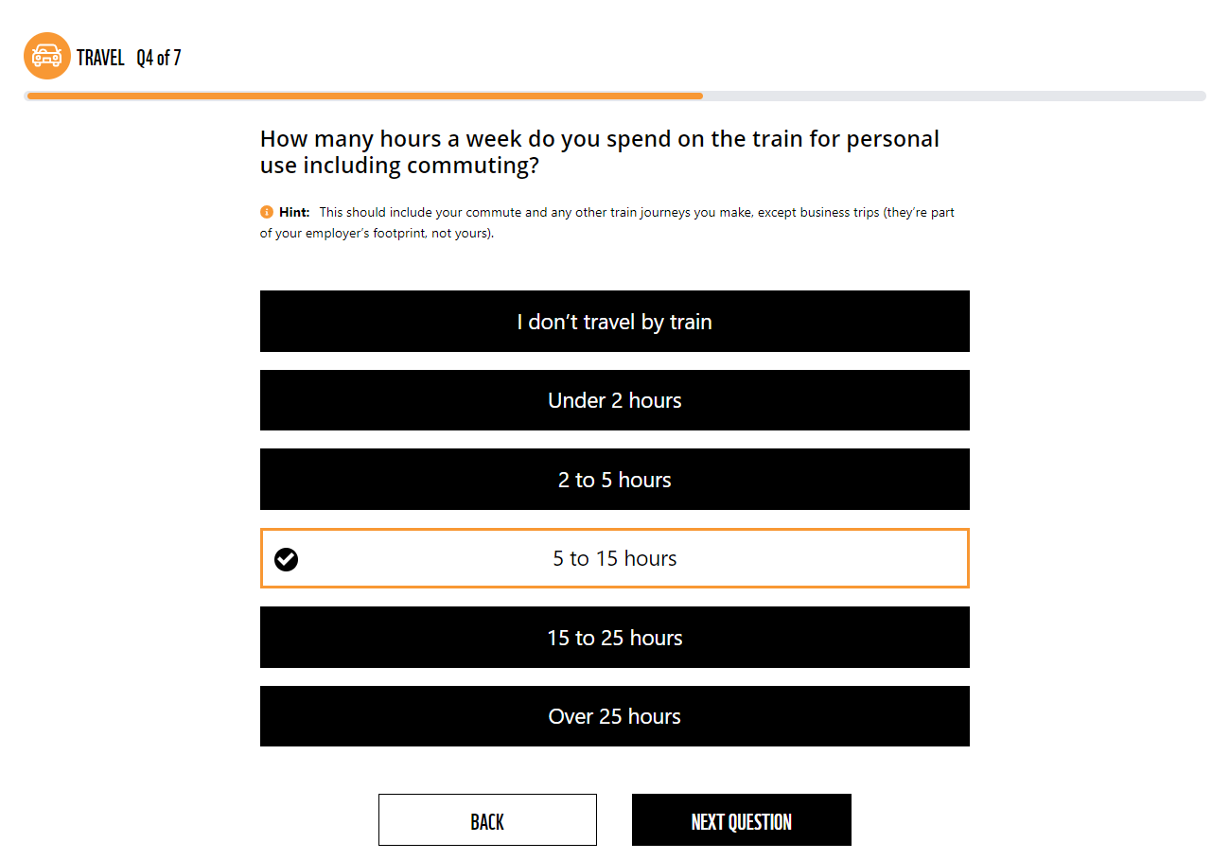

Q4-How many hours a week do you spend on the bus for personal use including commuting?

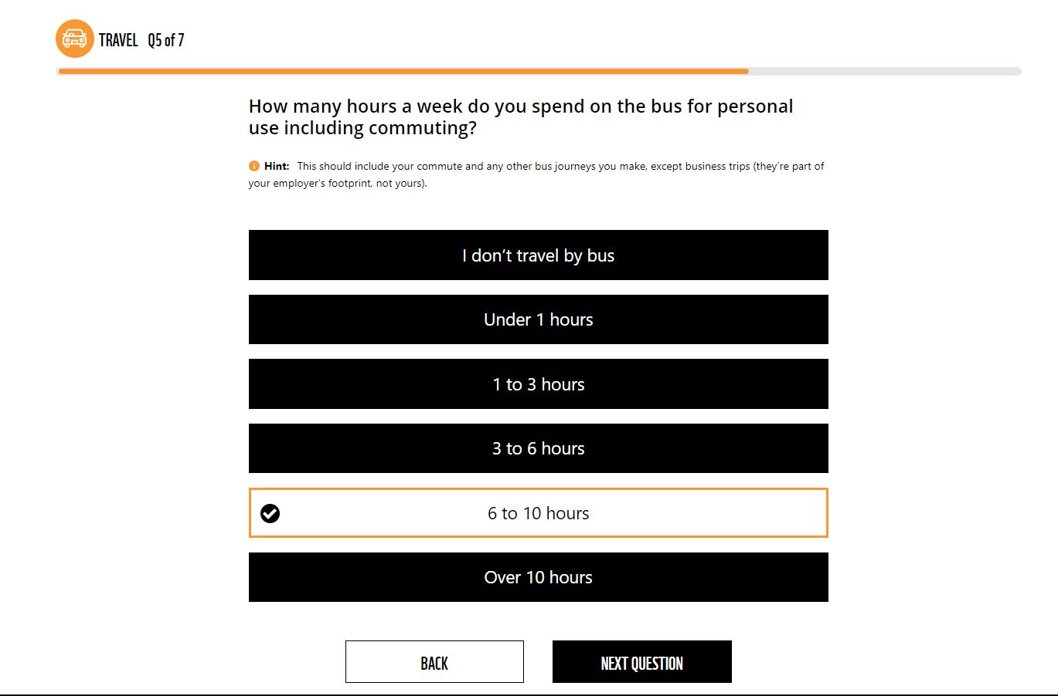
S

Q5-In the last year, how many return flights have you made in total to the following locations?

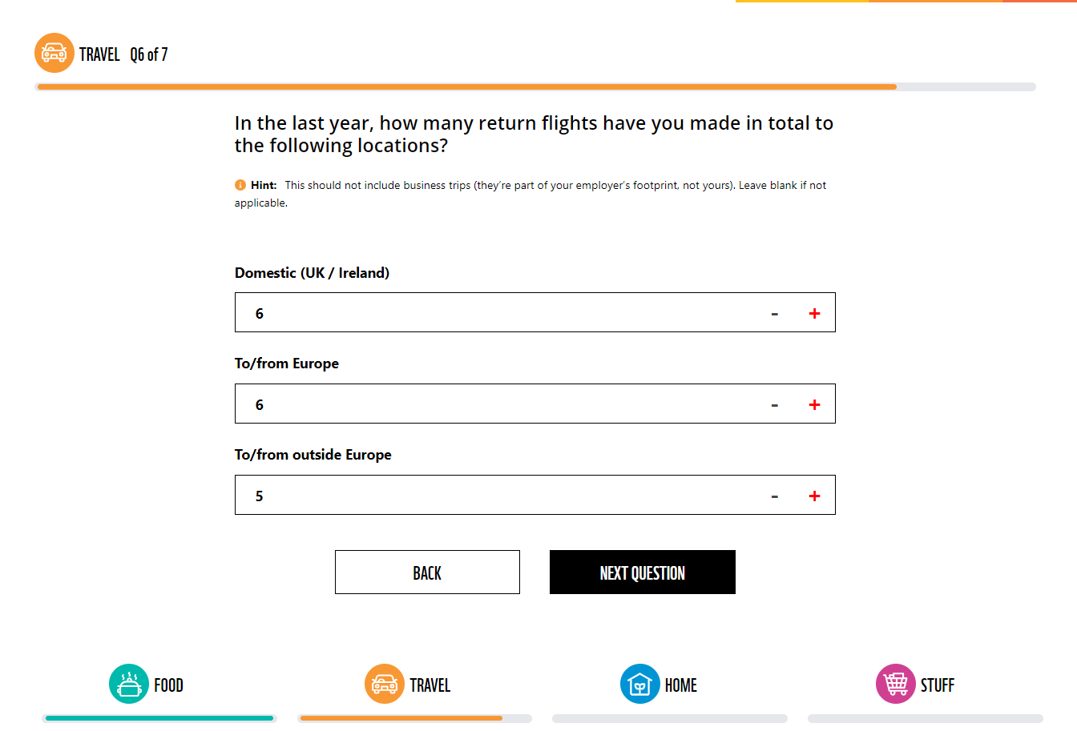
S

Q6-What percentage of your flights do you offset?
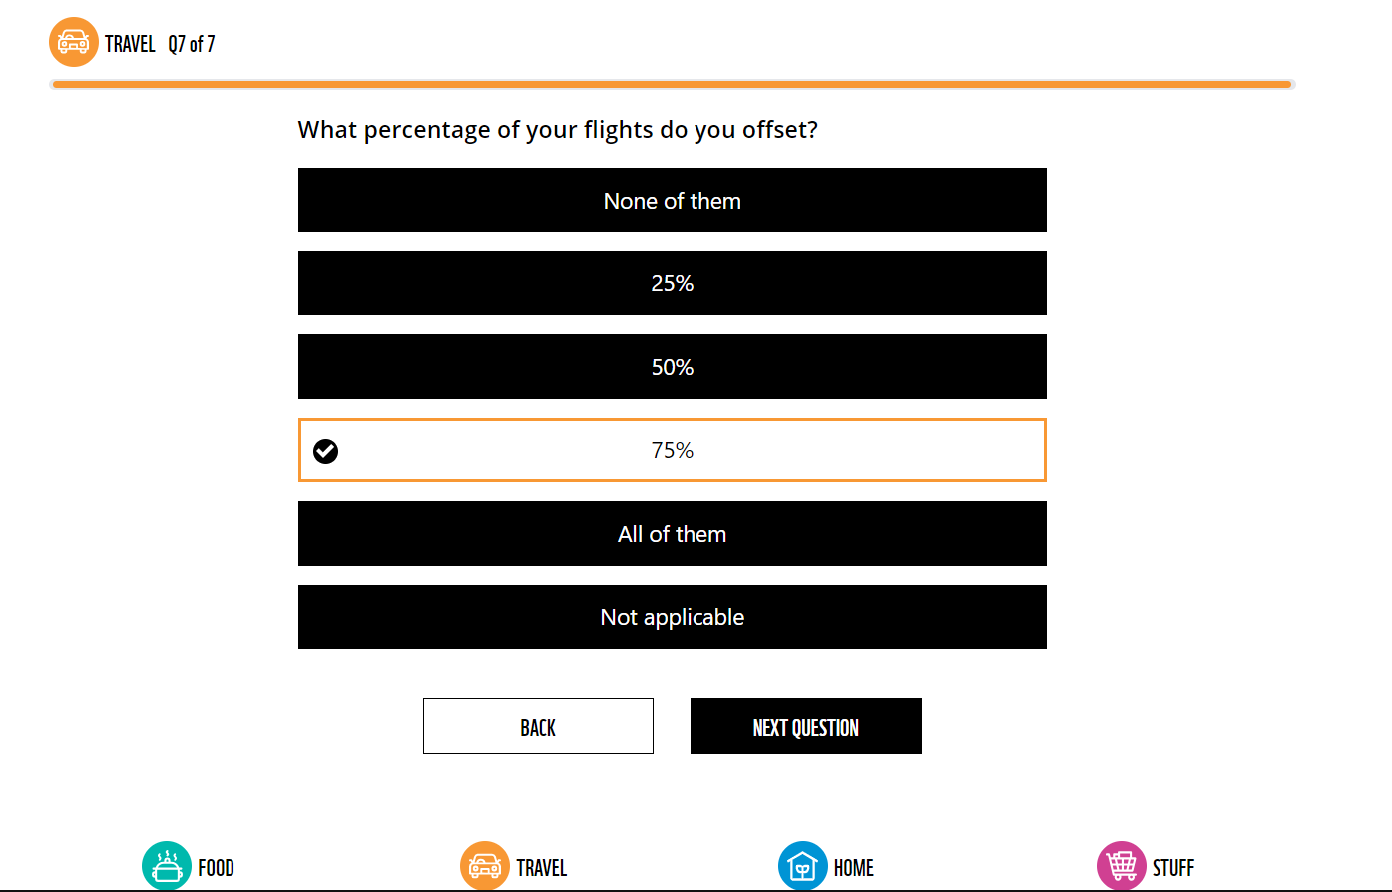
HOME

1- Amount spent monthly on electricity.
2- Amount spent on gas/heating in a certain period of time.
3- Do you regularly turn off the lights?

4-
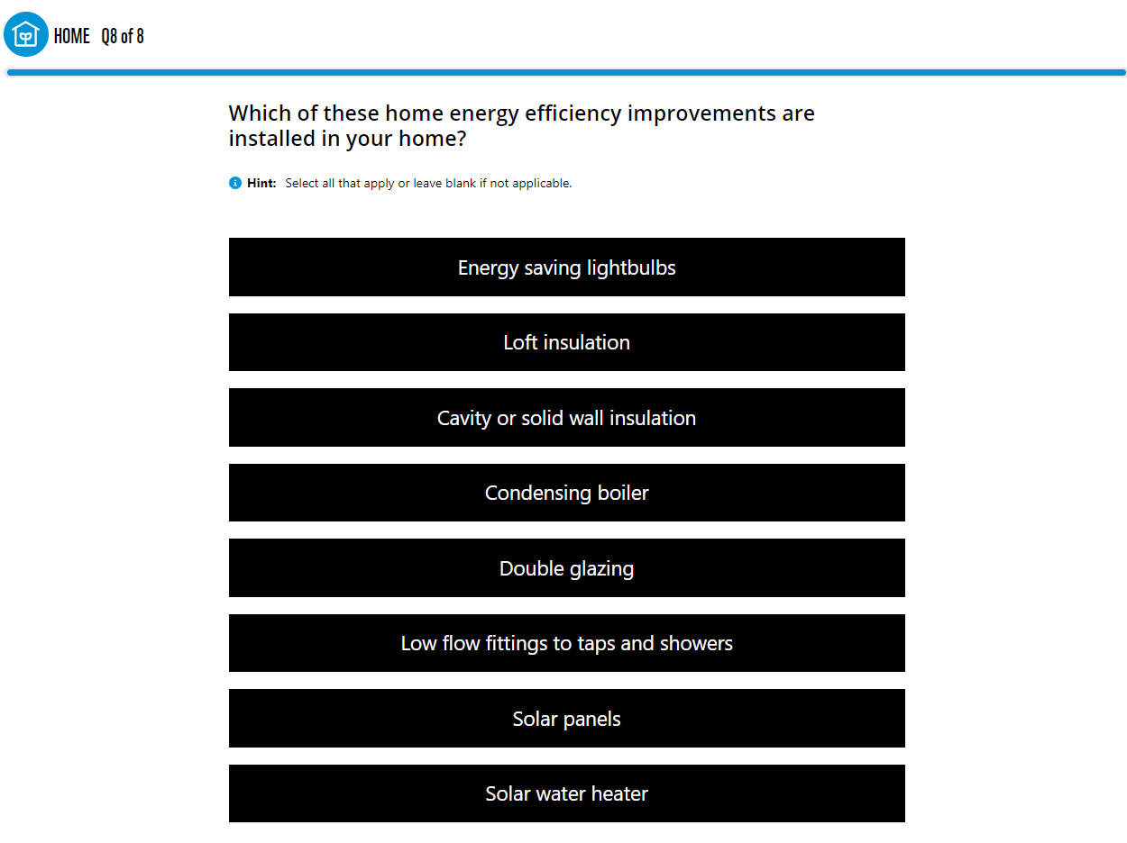
s

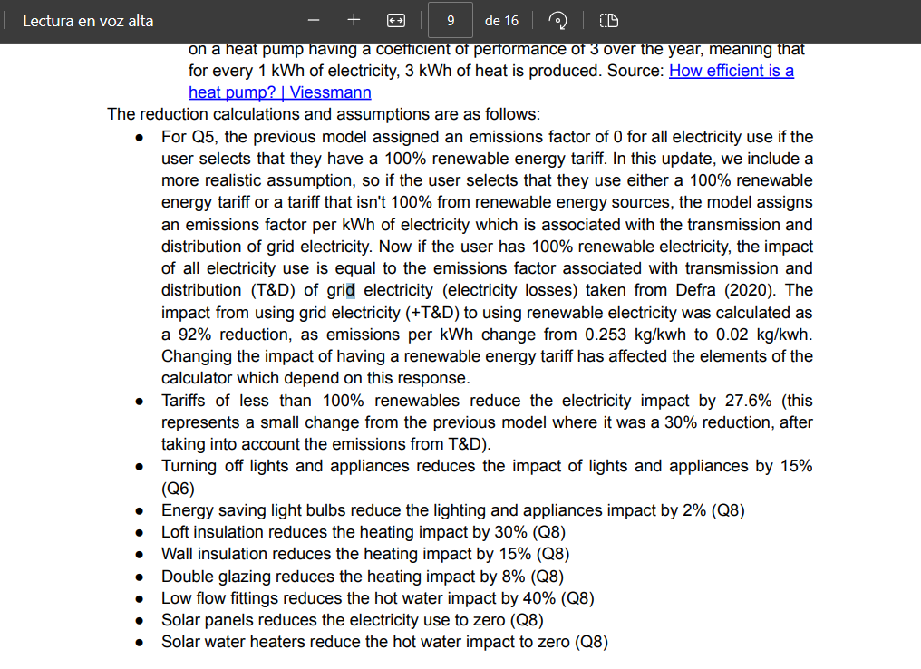
s

Each user has an additional 0.28 tCO2e added to their impact to reflect the per person costs of insuring and maintaining a home. This value is the average from the UK consumption emissions.

-Stuff

1-In the last 12 months, have you bought any of these new household items?
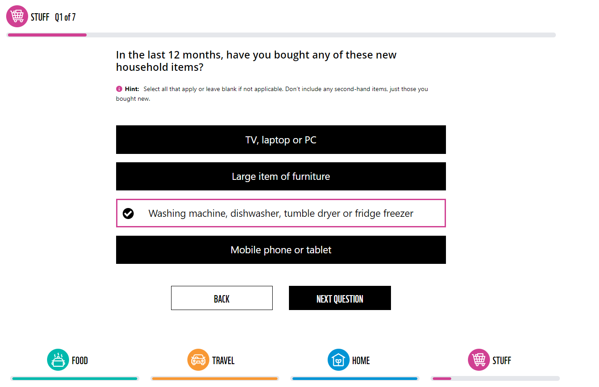

2-In a typical month, how much do you spend on clothes and footwear?
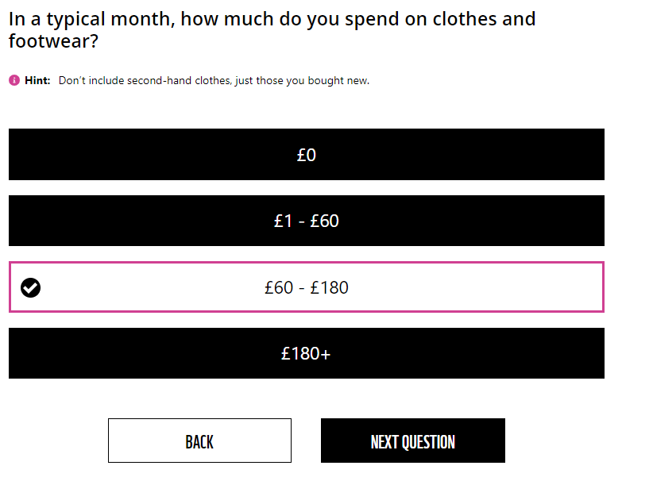

3-In a typical month, how much do you spend on your pets and pet food?
4-In a typical month, how much do you spend on health, beauty and grooming products?
5-In a typical month, how much do you spend on phone, internet and TV contracts?
6-In a typical month, how much do you spend on entertainment and hobbies (sports/gym, cinema, books, newspapers, gardening, computer games)
7-Which of these types of waste do you recycle and/or compost?

